**Hello World RESTful Web Service**   
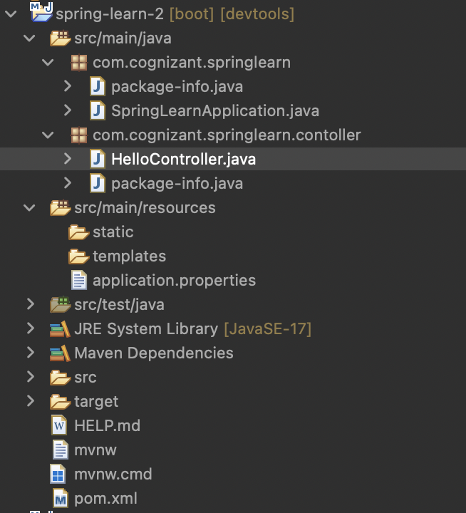

Project Structure:

package com.cognizant.springlearn;

import org.springframework.boot.SpringApplication;

import org.springframework.boot.autoconfigure.SpringBootApplication;

@SpringBootApplication

public class SpringLearnApplication {

public static void main(String[] args) {

SpringApplication.run(SpringLearnApplication.class, args);

}

}

package com.cognizant.springlearn.contoller;

import org.springframework.web.bind.annotation.GetMapping;

import org.springframework.web.bind.annotation.RestController;

@RestController

public class HelloController {

@GetMapping("/hello")

public String sayHello() {

return "Hello, Welcome to Spring Boot REST!";

}

}

<?xml version="1.0" encoding="UTF-8"?>

<project xmlns="http://maven.apache.org/POM/4.0.0" xmlns:xsi="http://www.w3.org/2001/XMLSchema-instance"

xsi:schemaLocation="http://maven.apache.org/POM/4.0.0 https://maven.apache.org/xsd/maven-4.0.0.xsd">

<modelVersion>4.0.0</modelVersion>

<parent>

<groupId>org.springframework.boot</groupId>

<artifactId>spring-boot-starter-parent</artifactId>

<version>3.5.3</version>

<relativePath/> <!-- lookup parent from repository -->

</parent>

<groupId>com.cognizant</groupId>

<artifactId>spring-learn-2</artifactId>

<version>0.0.1-SNAPSHOT</version>

<name>spring-learn-2</name>

<description>Demo project for Spring Data JPA and Hibernate</description>

<url/>

<licenses>

<license/>

</licenses>

<developers>

<developer/>

</developers>

<scm>

<connection/>

<developerConnection/>

<tag/>

<url/>

</scm>

<properties>

<java.version>17</java.version>

</properties>

<dependencies>

<dependency>

<groupId>org.springframework.boot</groupId>

<artifactId>spring-boot-starter-web</artifactId>

</dependency>

<dependency>

<groupId>org.springframework.boot</groupId>

<artifactId>spring-boot-devtools</artifactId>

<scope>runtime</scope>

<optional>true</optional>

</dependency>

<dependency>

<groupId>org.springframework.boot</groupId>

<artifactId>spring-boot-starter-test</artifactId>

<scope>test</scope>

</dependency>

</dependencies>

<build>

<plugins>

<plugin>

<groupId>org.springframework.boot</groupId>

<artifactId>spring-boot-maven-plugin</artifactId>

</plugin>

</plugins>

</build>

</project>

